**Single Board Computer OK3399-C based on Rockchip RK3399**

* OK3399-C single board computer (SBC) can serve as a development platform for both evaluation and application development purpose.
* It's integrated with GPU Mali-T864, can support OpenGL ES1.1/ 2.0/ 3.0/ 3.1, OpenVG1.1, OpenCL and DX11.
* It has on-board 2GB LPDDR3 RAM and 16GB eMMC.
* A variety of display interfaces such as HDMI2.0, MIPI-DSI, eDP1.3 and DP1.2 are all available and resolution up to 4K.
* Dual-screen both synchronous and asynchronous playing are well supported.
* OK3399-C comes with Android 7.1 and can be customized at the factory to suit your needs.

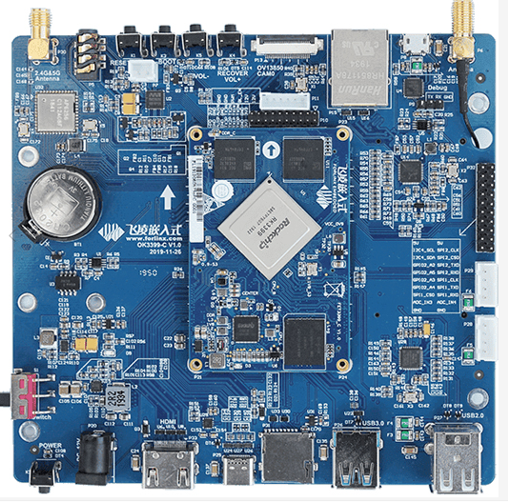

**Main Parameters of OK3399-C SBC**

* SoC- **Rockchip RK3399 Hexa-core processor** with 2 Arm Cortex-A72s up to 1.8 GHz, 4 Cortex-A53s up to 1.4 GHz, one Mali-T860 GPU, and a VPU decoding with 4K VP9 and 4K H265/H264;
* System memory - 2GB or 4GB LPDDR4;
* Storage - 16GB or 32GB, eMMC 5.1 storage;
* Video output - HDMI 2.0, AV port, MIPI DSI connector;
* Audio - MIC, Headphone/Speaker;
* Camera - MIPI-CSI connector b, support for 1x3 megapixel or 2x8 megapixel cameras;
* Connectivity - Gigabit Ethernet, Dual-Frequency WiFi 5 (802.11ac) and Bluetooth 5.0;
* USB - 2x USB 3.0 port, 2x USB 2.0 port;
* Extension - 40-pin Raspberry Pi compatible connector;
* Other - fan and RTC connectors, radiator mounts, Type-C interfaces;

**Target application**

* Self-service terminal
* Edge computing
* 5G Smart terminal
* POS machine
* Facial recognition

**Hexa-core processor**

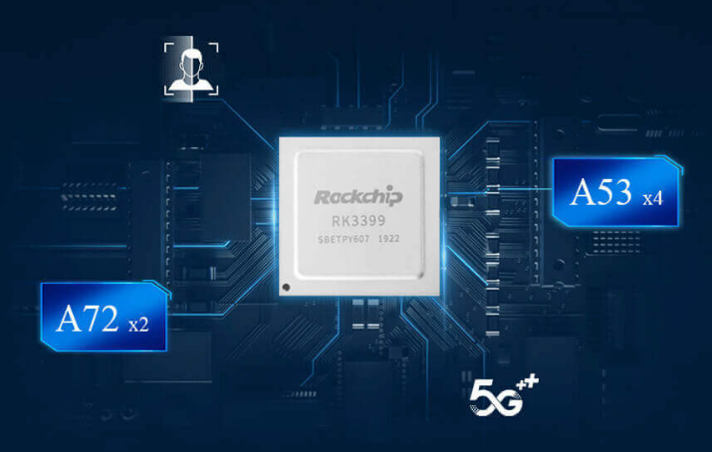FET3399-C SoM is based on Rockchip RK3399 processor which consists of two Cortex-A72 cores up to 1.8GHz and four Cortex-A53 cores up to 1.4GHz. GPU Mali-T864 can support OpenGL ES1.1/ 2.0/ 3.0/ 3.1, OpenVG1.1, OpenCL, DX11; with 2GB LPDDR3 on-board RAM (4GB upgradable) and 16GB eMMC.

**Various AI framework supporting**

FET3399-C Android7.1 is supported with Tensorflow Lite, Caffe and other related AI frameworks. The RK3399 is optimized with RKSSD specialy for deep learning related applications with supporting of OpenCL and RGA hardware engines to lower power consumption.



**RK3399 4K UHD**

4K VP9 and 4K 10bits H265/H264 video decoders, up to 60fps; Video post processor: de-interlace, de noise, enhancement for edge/detail/color.

**Multiplex display interfaces, can support dual-screen synchronous or asynchronous playing**

Dual VOP: one supports 4096x2160 with AFBC supported; the other supports 2560x1600; Dual channel MIPI-DSI (4 lanes per channel); eDP 1.3 (4 lanes with 10.8Gbps) to support display, with PSR; HDMI 2.0a for 4K 60Hz with HDCP 1.4/2.2; DisplayPort 1.2 (4 lanes, up to 4K 60Hz).

**Dual ISP**

Dual hardware ISP, can support up to one 13MPix/ s or dual 8MPix/ s, can support dual cameras input.

**High-speed connectors, OSP and misplug-proof designing**

SoM can be mounted to carrier board via four 80-pin ultra thin connectors with strong OSP performance, which guarantees high signal transaction reliability and protects contacts from touching and stain; Misplug-proof deisigning to avoid SoM failure by misplug operation.

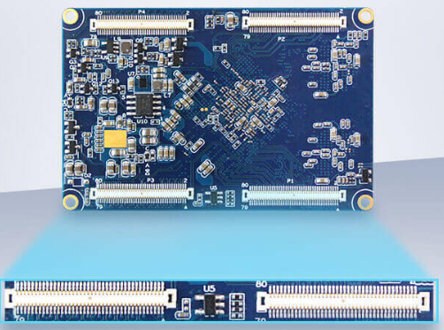

**OK3399-C SBC Block Diagram**

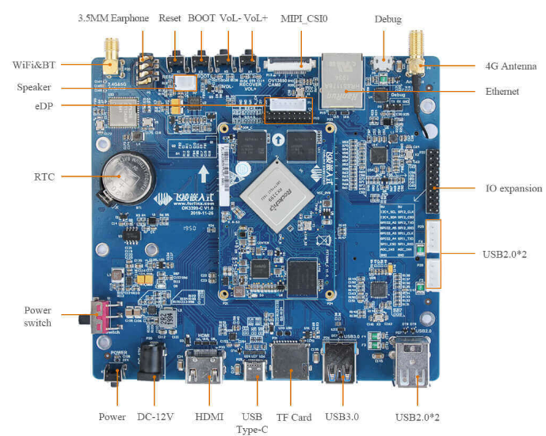

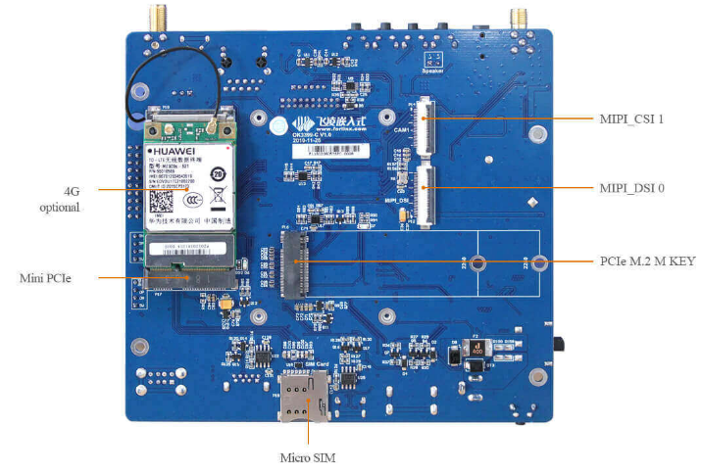

**Powerful and various communication channels**

OK3399-C has on-board Gigabit Ethernet interface, can support 2.4GHz & 5GHz WiFi, BT5.0, and also it's preserved with mini PCIe package for 4G LTE.

**Easy for evaluation and development**

All pins except standard peripherals are all drawn out by pin connectors with pitch of 2.54mm, including SPIx 2, IIC, ADCx 2, GPIOx 4. 2 USB2.0 Host are expanded by XH2.54 connectors which can be mounted with binocular camera or be used for serial expansion.

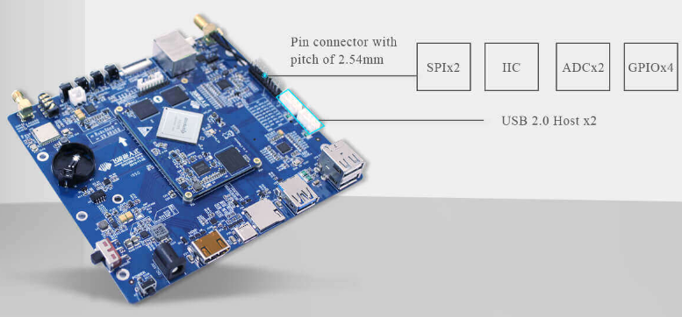

**Specifications**

|  |  |
| --- | --- |
| **CPU** | RK3399 hexa-core, Big.Little architecture  **Cortex-A72 Core:**  • 2x Cortex-A72  • up to 1.8GHz  • 64-bit Armv8  **Cortex-A53 Core:**  • 4x Cortex-A53  • up to 1.4GHz  • 64-bit Armv8 |
| **GPU** | **3D graphical engine:**  • quad-core Mali-T860MP4  • can support OpenGL ES1.1/2.0/3.0/3.1  • can support OpenCL 1.2  **2D graphical engine:**  • source form:  ARGB, RGB888, RGB565, RGB4444, RGB5551, YUV420, YUV422(SupportYUV422SP10bit/YUV420SP10bit)  • target form:  ARGB, RGB888, RGB565, RGB4444, RGB5551, YUV420, YUV422(SupportYVYU422/420 output)  • maximum resolution: source 8192x8192, and target 4096x4096 |
| **VPU** | **Decode:** • H.265/HEVC, up to 4Kx2K @ 60fps • VP9, up to 4Kx2K @ 60fps • H.264/AVC, up to 4Kx2K @ 30fps • MPEG-1, ISO/IEC 11172-2, up to1080P @ 60fps • MPEG-2, ISO/IEC 13818-2, up to 1080P @ 60fps • MPEG-4, ISO/IEC 14496-2, up to 1080P @ 60fps • VC-1, up to 1080P @ 60fps • MVC based on H.264 or H.265, up to 1080P @ 60fps **Encode:** • 1080p30 AVC/H.264 • 1080p30 VP8 |
| **RAM** | • 2GB(optional 4GB) • LPDDR3 1600 |
| **ROM** | • 16GB(optional 32GB) • eMMC 5.1 storage • HS400 mode |
| **Working Temperature** | 0℃~80℃ |
| **Dimensions** | 46mm x 70mm |
| **Voltage Input** | 12V |
| **OS** | Android 7.1, Linux* |

**Interface Specifications**

|  |  |
| --- | --- |
| **Display** | dual-screen engine up to 4096x 2160 and 2560x 1600, can output from below ports:  **MIPI-DSI ≤2** • CPU has 3 built-in MIPI PHY, MIPI0 can be only used as DSI, MIPI1 can be used as DSI or CSI, MIPI2 can be only used as CSI  • each DSI port has 4 data lanes, can support data transferring rate up to 6.0Gbps  • each DSI port can support output up to 1080P@ 60FPS  • MIPI0 and MIPI1 combination can support output 2560x 1600@ 60FPS  **eDPx1** • eDP V1.3  • RGB 6/ 8/ 10-bit  • 4 data lanes, each 2.7/ 1.62Gbps  • can support PSR  **DP x1** • Display Port V1.2  • compatible with HDCP2.2(backward compatible with HDCP1.3)  • only has one built-in DP controller, can output from Type-C*  • support outputting up to 4Kx 2K@ 60Hz  **HDMI x1** • HDMI1.4, HDMI2.0  • up to 18Gbps port trunks  • up to 180P@ 120Hz, 4Kx 2K@ 60Hz, QXGA@ 120Hz  • HDCP1.4/ 2.2 |
| **Audio** | **I2S/PCM x3** • I2S0/I2S2 can support 8-channel TX/RX. I2S1 can support -channel TX/RX • IIS2 internally connected to HDMI and DisplayPort, IIS0 and IIS1 are for peripherals • audio resolution from 16-bit to 32-bit • sampling rate up to 192KHz **SPDI** • can support two 16-bit audio data stored in one 32-bit width location • can support two-phase formed stereo audio output • can support 16-bit to 31-bit audio data left or right justified in 32-bit width sampling data frame zone • can support 16-bit, 20-bit, 24-bit audio data transferring in PCM mode • can support none-PCM mode |
| **Camera** | **MIPI CSI ≤2** • can support one 13.0MP camera or two 8.0MP cameras • two internal ISP • one ISP with resolution up to 14.0 MP **USB UVC** • USB UVC camera input |
| **USB Type-C** | **• USB Type-C x2(multiplexed with USB 3.0)** • USB Type-C 1.1 • can support USB3.0 Type-C and DP 1.2* can switch to USB Type-C mode • USB3.0 up to 5Gbps • DP1.2 up to 5.4Gbps(HBR2), can support 1/2/4 mode* • DisplayPort with AUX channel* |
| **USB OTG3.0** | **• USB OTG 3.0 x2(contains USB OTG 2.0 x2)** • compatible protocol: USB 3.0, USB 2.0, USB Host 1.1 • USB 3.0 in full-duplex mode up to 5Gbps band width |
| **USB 2.0** | **• USB 2.0 Host x2(separated, not multiplexed with 3.0)** • compatible with USB 2.0 • can support high speed mode(480Mbps), full speed mode (12Mbps) and low speed mode(1.5Mbps) |
| **SD/MMC** | **• SD/MMC x2** • can be configured to SD/MMC or SDIO • compatible with SDIO 3.0 • 4-bit data bus |
| **Ethernet** | **• Gigabit Ethernet x1** • RGMII is available for 10/100/1000-Mbps • RMII is available for 10/100-Mbps |
| **SPI** | **• SPI x5** • can support serial host and slave mode, software configurable • operation based on DMA or interrupt • TX and RX are 32x16-bit FIFO |
| **UART** | **• UART x5** • operation based on DMA or interrupt • TX and RX are 64Bytes FIFO • each serial up to 4.0 Mbps |
| **I2C** | **• I2C x7** • multi-host machine I2C • standard mode up to 100 kbit/s • fast mode up to 400 kbit/s |
| **PCIe** | **• PCIe x1** • compatible with PCI Express revised 2.1 • 4 full-plex channel • each channel can support 2.5GT/s to each direction • dual-operation mode: Root Complex(RC) and End Point(EP) |
| **PWM** | **• PWMs x3** • operation based on interrupt • 32-bit timer/ counter • can support capture mode • can support continuous mode or one-time mode |
| **ADC** | **• ADC x5** • successive approaching ADC • 10-bit • switch rate up to 1MS/ s for sampling |

**Hardware Features; Functional Interface Specifications:**

|  |  |
| --- | --- |
| **Power In** | DC12V |
| **HDMI** | • HDMI1.4, HDMI2.0  • up to 18Gbps port trunks  • up to 180P@ 120Hz, 4Kx 2K@ 60Hz, QXGA@ 120Hz  • HDCP1.4/ 2.2 |
| **USB Type-C** | • install or update system by USB type-C • USB Type-C 1.1 • can support mode switching between USB Type-C and DP1.2* • USB3.0 transferring rate up to 5Gbps • DP1.2 transferring rate up to 5.4Gbps(HBR2), can support 1/ 2/ 4 mode* • DisplayPort can support AUX channel* |
| **TF Card** | • install or update system by TF card • can support 1.8V* and 3.3V mode |
| **USB3.0** | • protocol: USB3.0, USB2.0, USB Host 1.1 • USB full-duplex mode transferring rate up to 5Gbps |
| **USB 2.0** | • USB 2.0 Host x4, USB 2.0 Host Type-A x 2 • expandable by HUB which is same with 4G and P28  • USB 2.0 Host XH2.54 x 2 • P29 is a native USB  • P28 is expanded by HUB |
| **IO Expand** | SPI x 2 • can support serial host and slave modes, software configurable • operation based on DMA or interrupt  • TX and RX are 32x16-bit FIFO UART x1 • it's configured to GPS in Android system • multi-plexed with SPI1 I2C x1 • multi-host IIC • standard mode up to 100 kbit/s • fast mode up to 400 kbit/s ADC x2 • successive approaching ADC • 10-bit • sampling rate up to GPIO x4 • 1.8V |
| **4G** | • Mini PCIe package |
| **Debug** | • Micro USB connector  • on-board USB to serial chip(CP2102) |
| **Ethernet** | • 10/100/1000-Mbps auto-negotiation, RJ 45 connector |
| **Camera** | • MIPI CSI x2 • can support 1x 13MP or 2x 8.0MP |
| **VoL** | • it's configured to audio volume adjusting keys in Android system • VoL+ is a Recover key, press it to start OTG flashing mode |
| **3.5mm Earphone** | • can support MIC and Headphone • CTIA standard and can support earphone line controlling |
| **Speaker** | • output consumption rate up to 1W • can support D-amplifier output |
| **WIFI& BT** | **• WIFI** • IEEE 802.11b/g/n & Wi-Fi AP 2.4GHz • IEEE 802.11a/n/ac & Wi-Fi AP 5GHz • SDIO3.0@ WiFi  **BT** • BT5.0  • UART/ PCM@ BT  • can support slave mode and slave mode |
| **eDP** | • eDP v1.3 • 4 data lanes, each 2.7/ 1.62 Gbps • supported with a 12V power interface, backlight enabled and backlight adjusted by PWM |
| **MIPI-DSI** | • 4 data lanes, each 6.0 Gbps • each up to 1080P@ 60FPS |
| **M.2** | • PCIe x 4 full-duplex  • each channel serial data transferring rate up to 2.5GT/ S to each direction  • M.2 KEY M connector  • preserved with 2260 and 2280 mounting holes for M.2 device  • can support NVMe static hard disk |